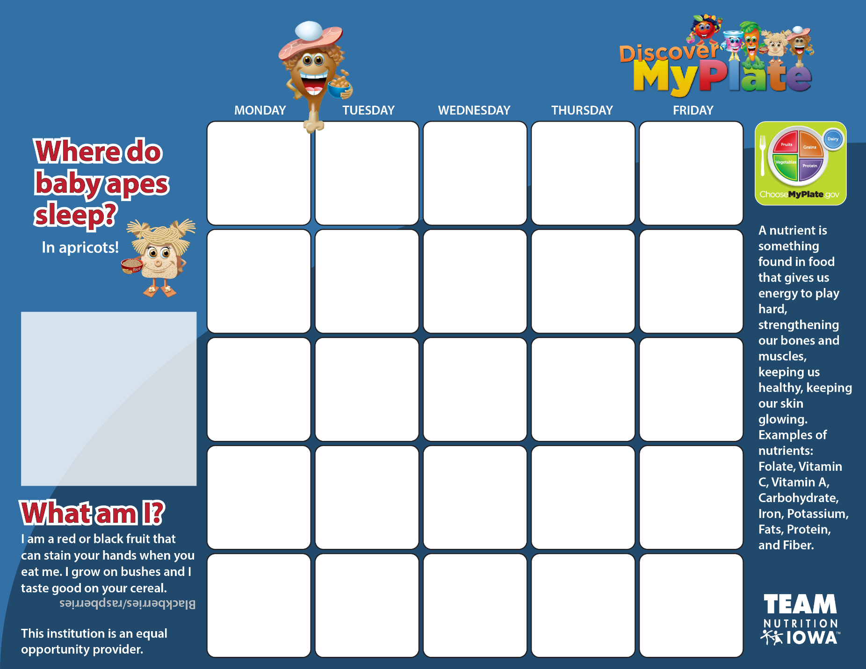

**School District Name**

**Month and Year**

Special announcement