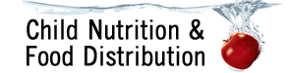
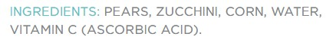
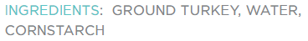
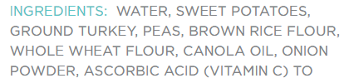
Foods for Infants in the CACFP
This handout provides a list of creditable and not creditable foods for the infant meal pattern:
- Page 1: Infant cereal and store-bought baby foods
- Page 2: Whole fruits and vegetables, meat/meat alternates
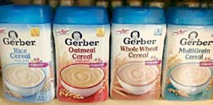
- Page 3: Grains (only creditable at snack)
Infant Cereal
- Iron-fortified (rice, oatmeal, multigrain) | × Not iron-fortified  × Dry cereal, containing fruit (ex. banana, apple)  × Jarred “wet” infant cereals  × Infant cereal served in a bottle  × Ready-to-eat cereal, enriched farina, regular oatmeal, and corn grits

Store-bought Fruits and Vegetables (Baby Food)
- Single fruit or vegetable (ex. peas) with a fruit or vegetable as the first ingredient  - Multiple fruits and/or vegetables (ex. pumpkin banana) with a fruit or vegetable as the first ingredient | × Water is first ingredient  × Jarred cereal, desserts, or puddings with fruit, including those that list fruit as the first ingredient  × Infant combination dinners, entrees, or meals with multiple component ingredients (ex. roast vegetable chicken dinner or lasagna dinner) that do not list the component contributions on the label

Store-Bought Meat & Meat Alternates (Baby Food)
- Meat or poultry is first ingredient  - Gravy and broth as additional ingredients are ok | × Infant combination dinners, entrees, or meals with multiple  component ingredients (ex. turkey rice dinner) that do not list the component contributions on the label
 |  |  | 1

Whole Fruits and Vegetables (Table Food)
- Fresh, canned or frozen fruits and vegetables are creditable. Vegetables should be cooked, if necessary, and pureed, mashed, or finely chopped for an infant to avoid choking. All foods served to infants must be of a shape, size and texture appropriate for the age and development of infant. | × Juice  × Foods deep-fat fried on-site  × Fruit based desserts  × Fruit snacks (such as 100% fruit strips or fruit leather, freeze-dried fruit snacks, fruit drops, or other snack-type products, including raisins)
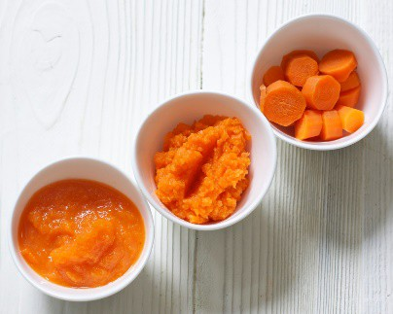
Meats & Meat Alternates (Table Food)
- Meat, fish, poultry (cooked, mashed, pureed, or small diced as needed to obtain appropriate texture and consistency)  - Processed meats and poultry such as chicken nuggets, hot dogs, fish sticks, sausage, and infant meat and poultry sticks (not dried or semi-dried, not jerky), are allowed but not recommended. Prepare them in a way to reduce choking.  - Cooked dry beans or cooked dry peas  - Cheese (natural, shredded), cottage cheese  - Whole eggs  - Yogurt (no more than 23 grams of sugar per 6 ounces) | × Cheese spread and cheese food  × Peanut butter and other nut or seed butters  × Nuts and seeds  × Tofu  × Soy yogurt  × Foods deep-fat fried on-site
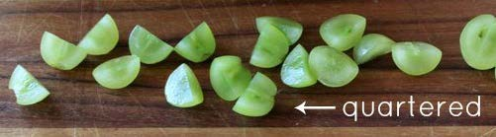
Practice Choking Prevention
- Avoid serving foods that are as wide around as a nickel
- Cut grapes, cherries, berries, melon balls and tomatoes into quarters
- Grate or thinly slice cheese
- Cook foods until soft enough to pierce with a fork
- Mash, puree or cut soft food into appropriate texture and/or size (i.e. thin slices or small pieces) per the infant’s development

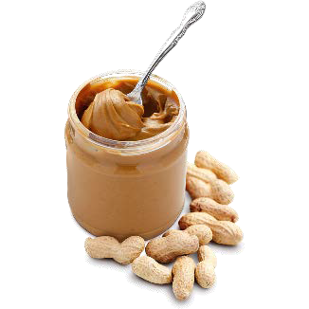
2

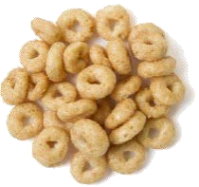
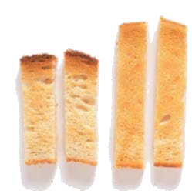
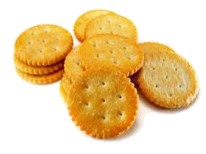
 | Creditable Grains can
 | only be served at snack
Grains:
Grains must be made from whole-grain or enriched meal or flour and made without nuts, seeds or hard pieces of whole grain kernels
- Bread  Breads, strips or small pieces of dry bread or toast Biscuits  Bagels  English muffins Pita bread Rolls  Soft tortillas Teething biscuits  - Crackers Saltines  Rounds, ovals, squares Small fish shaped  Graham and animal crackers  - Ready-to-eat Breakfast Cereal  Ready-to-eat breakfast cereal (no more than 6 grams of sugar per dry ounce) |  |  | × Popcorn  × Farina  × Oatmeal, instant and regular (Oatmeal is not a ready-to-eat cereal or iron-fortified infant cereal.)  × Puff cereal snacks and rice husk teething biscuits (Grains served to infants must be made with enriched or whole grain meal or flour or be fortified.)  × Grain Based Desserts, including: Cake, cupcakes, brownies  Cereal bars, breakfast bars, granola bars Cookies, including vanilla wafers  Sweet rolls, Toaster pastries, doughnuts Sweet bread pudding and rice pudding

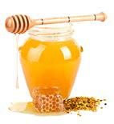

Honey, and foods that contain honey, should never be fed to babies less than 1 year of age. Honey may contain substances that can cause “infant botulism”, a serious type of food related illness that can make a baby very sick. Honey should not be added to food, water, or formula that is fed to babies, or used as an ingredient in cooking or baking (e.g. yogurt with honey, entrées and baked goods that contain honey). This also applies to commercially prepared foods such as cereals sweetened with honey or honey graham crackers.

3

This institution is an equal opportunity provider.

