Child Nutrition & Wellness

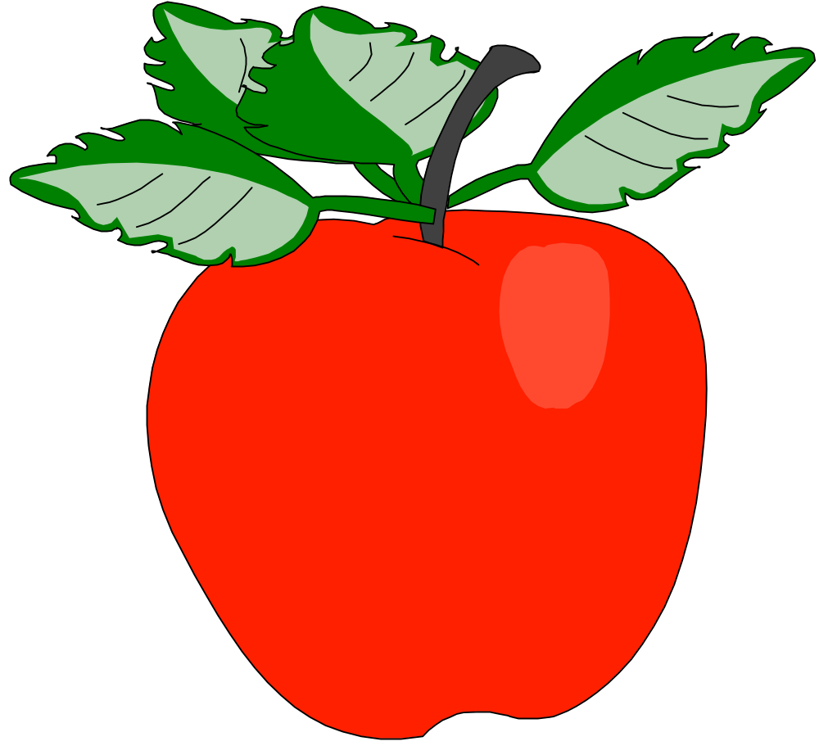
Kansas State Department of Education

Presents

Growing Healthier Futures with the CACFP


Training Manual

A Professional Development for Child Nutrition Program Employees

This publication has been funded at least in part with Federal funds from the U.S. Department of Agriculture, Food and Nutrition Service. The contents of this publication do not necessarily reflect the views or policies of the Department, nor does mention of trade names, commercial products, or organizations imply endorsement by the U.S. Government.

Kansas State Department of Education
Dr. Randy Watson, Commissioner, 785-296-3202
Dale M. Dennis, Deputy Commissioner, Fiscal & Administrative, 785-296-3871
Brad Neuenswander, Deputy Commissioner, Division of Learning Services, 785-296-2303
For further information, please contact: Child Nutrition & Wellness, KSDE, Landon State Office Building, 900 SW Jackson Street, Suite #251, Avenue, Topeka, Kansas 66612, 785-296-2276, Fax: 785-296-0232, www.kn-eat.org, Cindy L. Johnson, Training Coordinator, cljohnson@ksde.org.

In accordance with Federal civil rights law and U.S. Department of Agriculture (USDA) civil rights regulations and policies, the USDA, its Agencies, offices, and employees, and institutions participating in or administering USDA programs are prohibited from discriminating based on race, color, national origin, sex, disability, age, or reprisal or retaliation for prior civil rights activity in any program or activity conducted or funded by USDA.

Persons with disabilities who require alternative means of communication for program information (e.g. Braille, large print, audiotape, American Sign Language, etc.), should contact the Agency (State or local) where they applied for benefits. Individuals who are deaf, hard of hearing or have speech disabilities may contact USDA through the Federal Relay Service at (800) 877-8339. Additionally, program information may be made available in languages other than English.

To file a program complaint of discrimination, complete the USDA Program Discrimination Complaint Form, (AD-3027) found online at: http://www.ascr.usda.gov/complaint_filing_cust.html, and at any USDA office, or write a letter addressed to USDA and provide in the letter all of the information requested in the form. To request a copy of the complaint form, call (866) 632-9992. Submit your completed form or letter to USDA by:

- Mail: U.S. Department of Agriculture
Office of the Assistant Secretary for Civil Rights
1400 Independence Avenue, SW
Washington, D.C. 20250-9410;

- Fax: (202) 690-7442; or

- Email: program.intake@usda.gov.

This institution is an equal opportunity provider.

The following person has been designated to handle inquiries regarding the non-discrimination policies at the Kansas State Department of Education: Office of General Counsel, Landon State Office Building, 900 SW Jackson St, Suite #102, Topeka, KS 66612, (785)296-3201.

Publication Date: Spring 2018

Growing a Healthier Future with CACFP!

Administration

This class was developed by Child Nutrition & Wellness, Kansas State Department of Education. Class content and activities were adapted from the following sources:

- https://www.fns.usda.gov/tn/nutrition-wellness-tips-young-children, December 2017
- https://fns-prod.azureedge.net/sites/default/files/cacfp/CACFP_factBP.pdf, December 2017
- http://choosemyplate.gov, December 2017
- CACFP 15-2016
- http://www.montana.edu/mtfarmtoschool/resources/farm-to-preschool.html, January 2018
- http://www.farmtoschool.org/Resources/Local%20Purchasing%20for%20Family%20Child%20Care%20Providers.pdf, January 2018
- https://www.fns.usda.gov/tn/team-nutrition, January 2018
- https://www.fns.usda.gov/tn/cacfp-meal-pattern-training-tools, January 2018
- http://www.theicn.org/ResourceOverview.aspx?ID=527, January 2018
- https://fns-prod.azureedge.net/sites/default/files/quality_veg.pdf, January 2018
- https://www.ars.usda.gov, January 2018
- http://nfsmi.org/ResourceOverview.aspx?ID=247, January 2018
- https://snaped.fns.usda.gov/seasonal-produce-guide/brussels-sprouts, January 2018
- http://foodandhealth.com/clipart.php/category/21/, January 2018
- https://www.fruitsandveggiesmorematters.org/lima-beans, January 2018

* Growing a Healthier Future with CACFP *
Administration
Table of Contents

Lesson Outline Page 1

Facility Requirements Page 2

Preparation and Set-up Instructions Page 2

Supplies Needed Page 3

Vegetable Food Cards Page 4
- 1 color copy on white cardstock, cut into individual cards (provided by KSDE)

Vegetable Sub-Group Answer Key Page 12

Top it Off Suggestions Page 13

Best Practice vs Meal Pattern Requirement Kahoot Q&A’s Page 14

Healthier CACFP Award Interest Sign-Up Sheet Page 15

Signs (Welcome, Restroom, Arrow) Page 16
- copies can be made as needed

Participant Booklet Separate Word File
- black and white copies, copy cover and Acknowledgments/Discrimination Statement page back-to-back on colored paper and remaining pages back-to-back on white paper, put blank colored page at end of packet, staple in top, left corner, one booklet per participant (provided by KSDE)

Healthier CACFP Award Application Separate Word File

Child Nutrition & Wellness
Kansas State Department of Education

Lesson Outline

Topic | Estimated Time
Welcome and Introduction  Objectives  CACFP Best Practices  Healthier CACFP Award | 10 minutes
Best Practices: Infants  Activity 1: Healthier CACFP Award – Infant Care (5 minutes) | 10 minutes
Best Practices: Vegetables and Fruits  Activity 2: Vegetable Sub-Group Activity (10 minutes)  Activity 3: Making Foods Sound Fun Enough to Eat (10 minutes) | 30 minutes
Best Practices: Milk  Activity 4: Healthier CACFP Award – Menus (5 minutes)  Best Practices: Grains | 15 minutes
Best Practices: Meat/Meat Alternate  Activity 5: Healthier CACFP Award – Menus (5 minutes)  Healthier Kansas Menus – CACFP  Recipe Resources | 20 minutes
Additional Best Practices  Activity 6: Top It Off Activity (5-10 minutes)  Activity 7: Healthier CACFP Award – Menus (5 minutes) | 25 minutes
Activity 8: Kahoot Best Practice or  Requirement Activity (15 minutes) | 15 minutes
Healthier CACFP Award  Goal Setting  Activity 9: Goal Setting (10 minutes)  Wrap-Up & Questions | 25 minutes
TOTAL TIME | 2.5 hours

Facility Requirements

Classroom

- Comfortable chairs and tables for participants to work in small group activities
- Blank wall or space for a screen at the front of the room
- Table located near the blank wall or screen for the trainer’s materials

Media Equipment

- Data projector/computer
- Audio capabilities
- Screen or light colored blank wall at the front of the room

Preparation and Set-Up Instructions

Organizer

- Copy Participant Booklets.
- Copy and cut Vegetable Food Cards

Host Site

- Ensure that the classroom is clean and meets the requirements.
- Ensure temperature controls are in place.
- Ensure media equipment is in good working condition.

Trainer

- Read class notes in advance and prepare.
- Prepare the sticky poster sheets for vegetable sub-group activity

Supplies Needed

Item | Description | Amount  Needed | Provided by
Clock or watch | Activities | 1 each | Trainer
Pencils | For participants who  did not bring one | 12 each | KSDE or Trainer
Marker | For vegetable sub-group activity | 1 each | KSDE or Trainer
Masking Tape | For vegetable sub-group activity | 1 roll | KSDE or Trainer
Sticky Poster Paper | For vegetable Sub-Group Activity | 5 sheets per class | KSDE
Vegetable Food Cards | For vegetable Sub-Group Activity | 1 set/class | KSDE

Vegetable Food Cards

Bok Choy  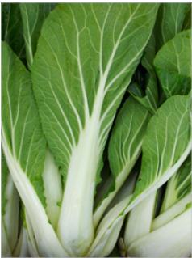 | Broccoli  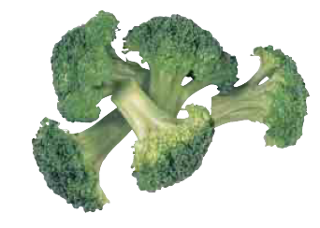
Collard Greens  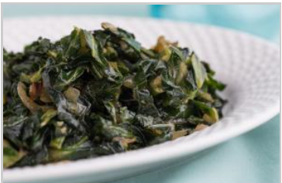 | Iceberg Lettuce  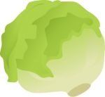
Kale  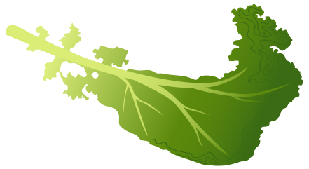 | Mesclun  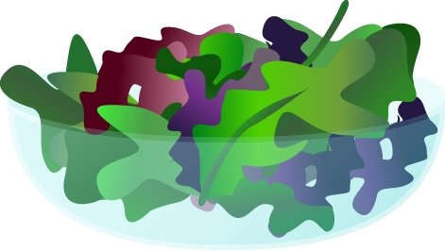
Snap Peas  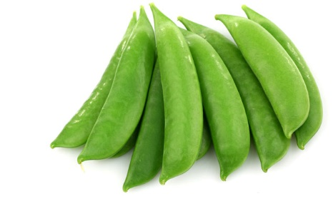 | Romaine Lettuce  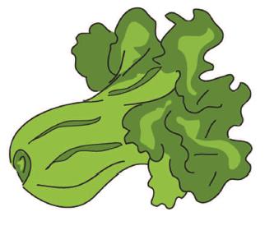
Spinach  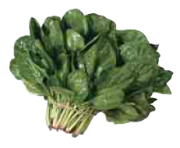 | Swiss Chard  
Mushrooms  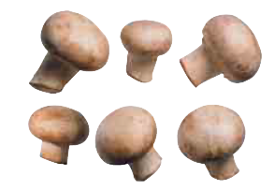 | Acorn Squash  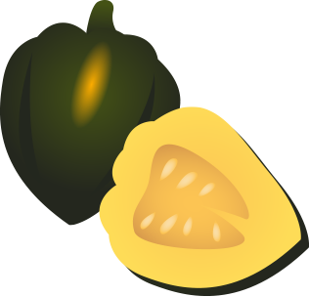
Butternut Squash  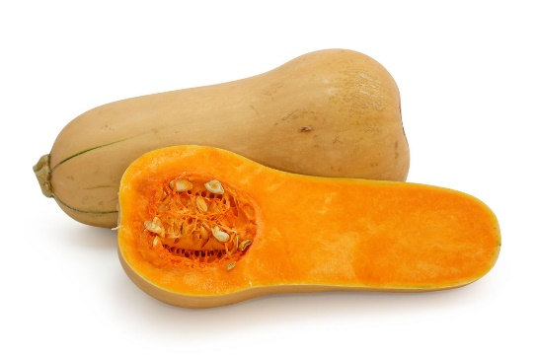 | Carrots  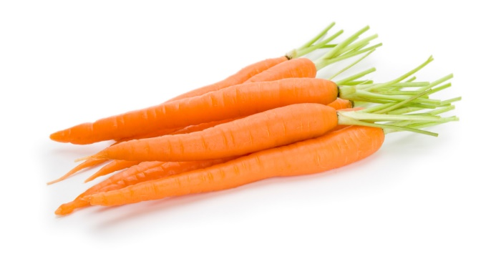
Edamame  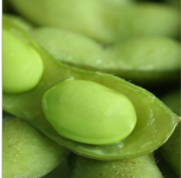 | Pumpkin  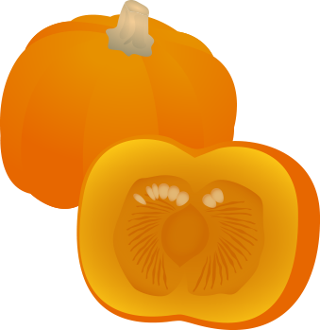
Red Peppers  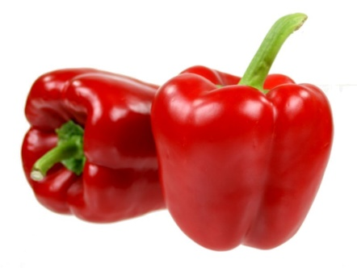 | Sweet Potatoes  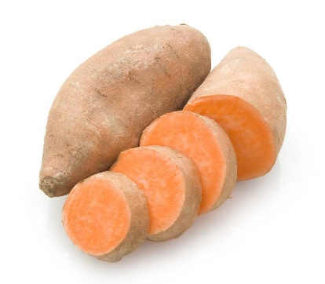
Tomatoes  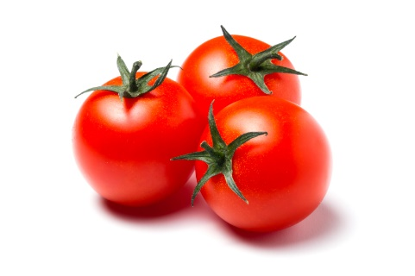 | Tomato Juice  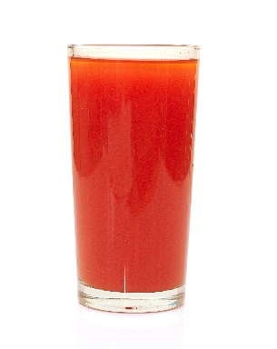
Zucchini  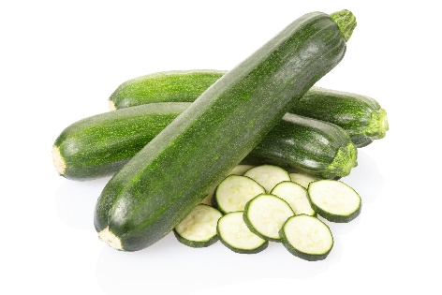 | Asparagus  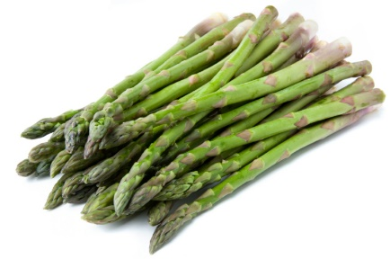
Avocado  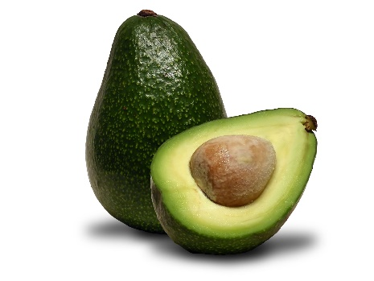 | Beets  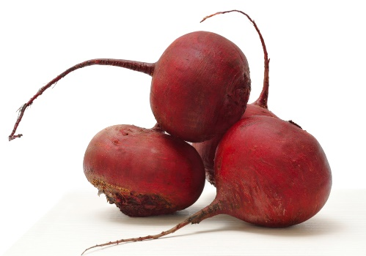
Brussels Sprouts   | Cabbage  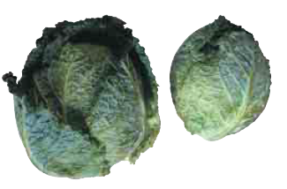
Cauliflower  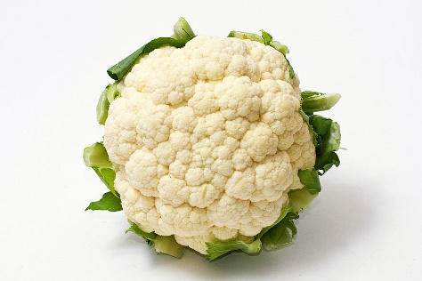 | Celery  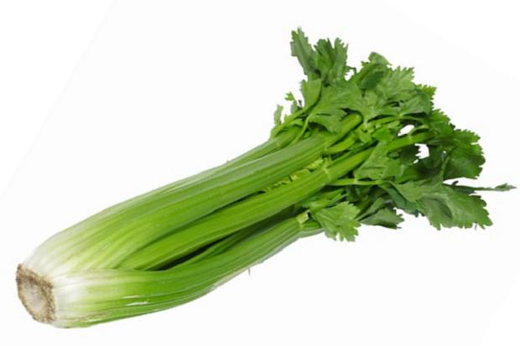
Crookneck Squash  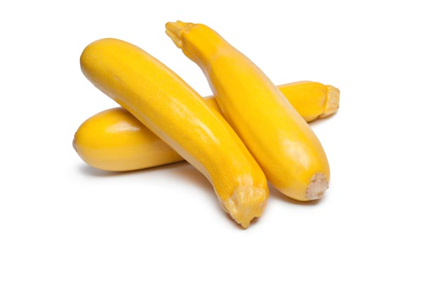 | Cucumbers  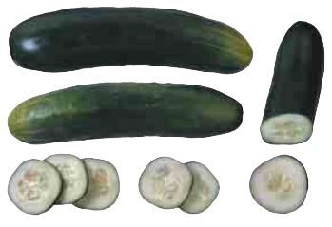
Eggplant  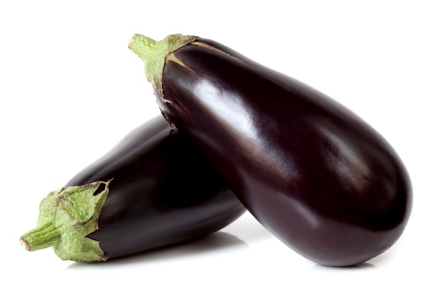 | Split Peas  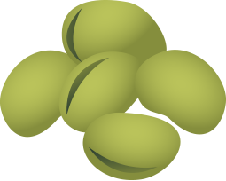
Corn  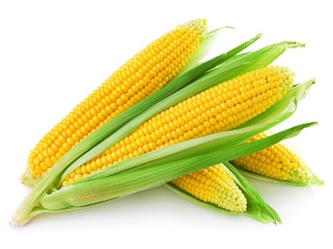 | Jicama  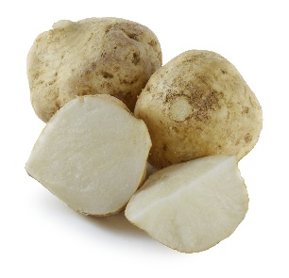
Green peas  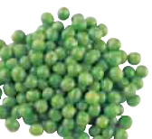 | Green Lima Beans  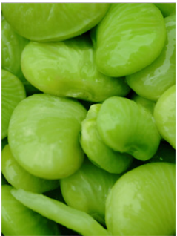
Plantains  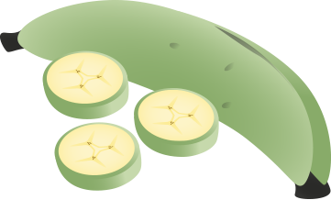 | Potatoes  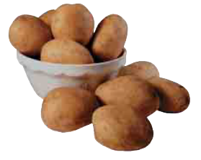
Green Bell Peppers  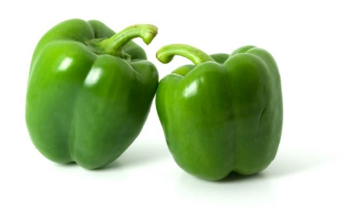 | Green Beans  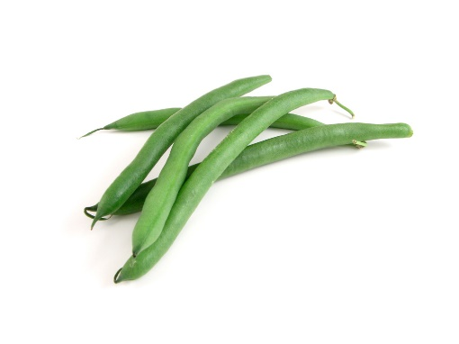
Black Beans  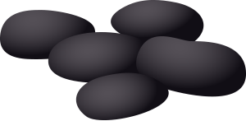 | Black-Eyed Peas  
Chickpeas (Garbanzo Beans)  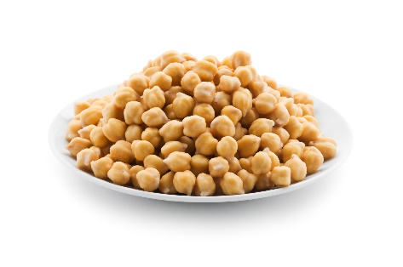 | Kidney Beans  
Radishes  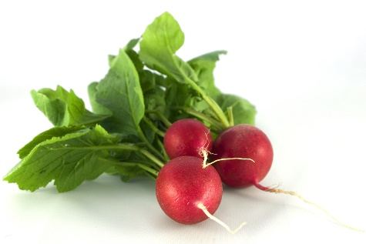 | Navy Beans  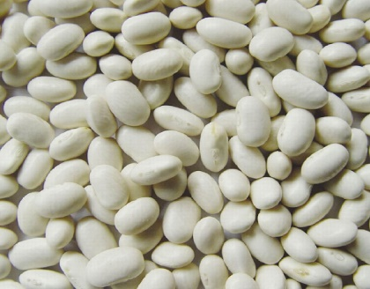
Pinto Beans  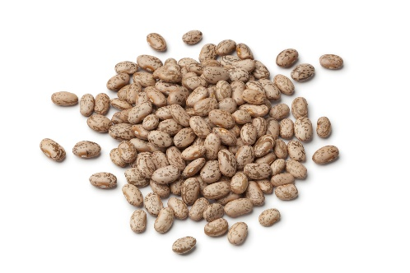 | Okra  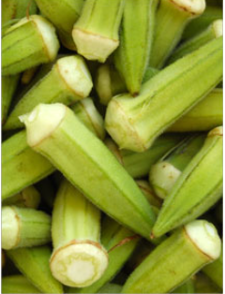

Vegetable Sub-Group Answer Key

Dark-Green Vegetables:
Bok Choy
Broccoli
Collard Greens
Kale
Mesclun
Romaine lettuce
Spinach
Swiss chard

Red and Orange Vegetables:
Acorn squash
Butternut squash
Carrots
Pumpkin
Red peppers
Sweet potatoes
Tomatoes
Tomato juice

Starchy Vegetables:
Corn
Green peas
Green lima beans
Jicama
Plantains
Potatoes

Dry Beans and Peas:
Black beans
Black-eyed peas
Chickpeas (garbanzo beans)
Kidney beans
Navy beans
Pinto beans
Soy beans (edamame)
Split peas
White beans

Other Vegetables:
Asparagus
Avocado
Beets
Brussels sprouts
Cabbage
Cauliflower
Celery
Crookneck squash
Cucumbers
Eggplant
Green beans
Green peppers
Iceberg lettuce
Mushrooms
Radishes
Snap Peas
Okra
Zucchini

Top It Off Suggestions

Brainstorm creditable toppings for the following food items.

Toast  - Fruit faces – yogurt smeared on toast, blueberries for hair, banana slices for eyes, strawberry for nose and apple slice for mouth. Be Creative – Let Kids be Creative!  - Applesauce with cinnamon sprinkled on top  - Refried beans with salsa  - Nacho toast – salsa, green onions and cheese – bake  - See biscuit ideas and rice cake ideas | Biscuits  - Mashed avocado  - Peanut butter with granola  - Light cream cheese with fresh fruit  - Peanut butter with sliced banana  - Scrambled or Hard Egg  - Hummus  - Applesauce with cinnamon sprinkled on top  - Cottage cheese with cherry tomatoes  - See toast and rice cake ideas
Pancakes/Waffles  - Fresh fruit – make a funny face!  - Yogurt  - Cook fruit into the batter  - Nut butter  - Cooked fruit (blueberries, peaches, apples, etc)  - Applesauce  - Fresh peaches with vanilla yogurt  - Applebutter  - Fruit Salsa | Rice Cakes  - Nut butter with strawberries or bananas  - Hummus with veggies – make a fun face!  - Light cream cheese with deli meat  - Cottage cheese with sliced tomato or pineapple ring  - Avocado  - Pizza sauce, mozzarella cheese  - Egg or tuna salad  - See toast and biscuit ideas
Yogurt  - Whole grain granola or cereal  - Fresh seasonal fruit  - Frozen fruit  - Canned fruit  - Dried fruit  - Baked fruit  - Mashed banana and cinnamon  - Nut butter | Notes:

Best Practice vs Meal Pattern Requirement
Kahoot Questions & Answers

Is it a meal pattern requirement or best practice to:

- Offer a quiet, private area that is comfortable and sanitary for mothers to breastfed or pump – BP
- Make at least one of the two components of snack a vegetable or fruit for adults and children one year of age and older– BP
- Limit serving fruit juice to no more than one time per day for children one year and older – MPR
- Provide at least one serving of each vegetable sub-group per week – BP
- Not serving juice to infants – MPR
- Have a Child Nutrition Label for convenience products – MPR
- Not counting grain-based desserts towards the grain component - MPR
- Serve processed meats no more than one time per week – BP
- Serve only natural cheeses and choose low-fat or reduced-fat cheese – BP
- Make water available throughout the day to adult participants – BP
- Serve unflavored milk to children 1-5 years old - MPR
- Gradually introduce solid foods around 6 months of age, as developmentally appropriate – MPR
- Incorporate seasonal and locally produced foods into meals – BP
- Serve a vegetable or fruit at snack for infants 6 through 11 months old – MPR

Healthier CACFP Award Interest
Sign-Up Sheet

Interested in applying for a Healthier CACFP Award? Sign-up so a KSDE staff person can follow-up and assist you with the application process!

Name | Center Name | Email | Phone Number

Welcome
To

Growing a Healthier Future with CACFP

______________________
Restrooms




