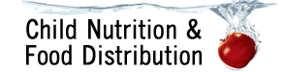
Smoothies in CACFP

Smoothies prepared by the program:
  - Milk, fruit, vegetables, fruit/vegetable juice and yogurt can credit in a smoothie
  - Milk used in smoothies must meet the federal requirements of fluid milk for each age group
  - Pureed fruit and vegetables credit as juice when served in a smoothie
    - Amount based on volume after pureeing, before including in smoothie
    - Juice can only be served at one meal or snack per day, this includes when served in a smoothie
  - Yogurt may be regular or soy
    - Yogurt credits as meat/meat alternate, not fluid milk
    - Yogurt must meet the sugar limits
  - Grains and other meat/meat alternates (such as peanut butter or tofu) do not credit to the meal pattern when served in a smoothie, but may be included to improve flavor and consistency
  - All components must be offered in the required quantities to meet the meal pattern requirements
  - Smoothies may be served at any meal or snack
- Snack: A smoothie containing fruit/vegetable and milk can credit as either juice or milk, not both. There must be a separate, second creditable component served in addition to the fruit/vegetable and milk smoothie. Juice may not be served when milk is the only other component.
*Refer to the CACFP meal pattern for required minimum amounts for each age group
Crediting*
½ cup milk
½ cup fruit juice
1 oz. meat alternate
Ingredient
4 fluid oz. fat free milk
½ cup blueberry puree, frozen 4 oz. low fat yogurt
Recipe for a Creditable Smoothie
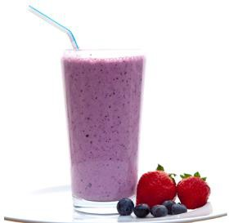

Commercially prepared smoothies:
  - May only credit towards the fruit or vegetable components
- Products that have a label which includes a statement regarding the “percent juice content” is required for beverages made with fruit and/or vegetable juice or puree
- Only the portion of 100% juice can credit towards the fruit or vegetable component
  - Ex. An 8.0 fluid ounce smoothie made from fruit puree with juice content labeled as “contains 50% juice” credits as 4.0 fluid ounces or ½ cup of juice

  - Prepackaged smoothies do not comply with standard of identity for “milk” or “yogurt” and do not
meet the Child Nutrition Program requirements for “fluid milk” or “yogurt.”

USDA Memo SP 10-2014 (v.3), CACFP 05-2014 (v.3), SFSP 10 -2014 (v.3)

North Dakota Department of Public Instruction www.nd.gov/dpi/
This institution is an equal opportunity provider.

