New Creditable Foods for Child Nutrition Programs

The following foods are now creditable at meals and snacks for the Child and Adult Care Food Program (CACFP).

SHELF-STABLE, DRIED AND SEMI-DRIED MEAT, POULTRY, AND SEAFOOD PRODUCTS
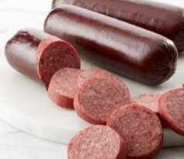
Shelf-stable, dried and semi-dried meat, poultry, and seafood, such as beef jerky or summer sausage are creditable as meat.
- To credit these products, programs must obtain and use Child Nutrition (CN) labels or Product Formulation Statements (PFS) from the manufacturer.

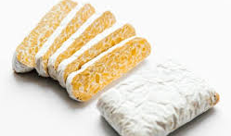
TEMPEH
Tempeh is a fermented soybean cake made from whole soybeans or other beans/legumes and grains and is creditable as a meat alternate.

1 oz. of tempeh credits as 1 oz. meat alternate for tempeh
with ingredients limited to soybeans (or other legumes), water, tempeh culture,* vinegar, seasonings, and herbs
- Varieties of tempeh that include other creditable foods as ingredients, such as brown rice, sunflower seeds, sesame seeds, flax seed, and/or vegetables, may also credit as meat alternates, grains, and/or vegetables using a PFS or CN label.
* Tempeh culture may be listed on the ingredients label as rhizopus oligosporous culture, rhizopus culture, rhizopus, tempeh culture, or starter culture
- A vegetarian option that can be used in recipes including
stir-fries, sandwiches, and salads.

COCONUT
Fresh or frozen coconut credits as a fruit based on volume served.
- At least 1/8 cup must be served (with additional fruit served to meet the minimum requirement).
- Can be used to enhance the taste and presentation of salads, smoothies, and other dishes served with meals or as snacks.
- 100% juice that includes coconut water as an ingredient credits toward the fruit component per volume served.
- Dried coconut, coconut flour, and oil are not creditable.

HOMINY
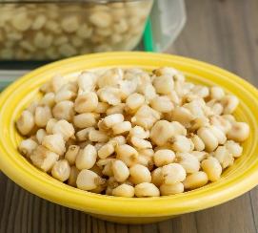
Traditional food in Mexican and Native American cultures. Credits as a vegetable or whole grain (depending on how it is offered).

Type of Hominy | Serving Size | Creditable Component
Whole form  (canned, drained) | ¼ cup | ¼ cup Vegetable
Cooked dry form (grits) | ½ cup cooked or 1 oz. (28 g) | 1 oz. eq. Grain (WGR)

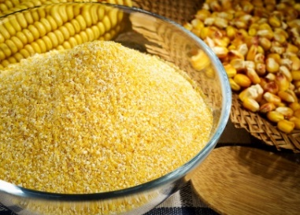
CORN MASA, CORN FLOUR, and CORNMEAL
Corn masa, corn flour, and cornmeal are creditable as whole grain rich (WGR) ingredients.
- Used for making tortilla chips, taco shells, tamales, pupusas, and other popular corn products.
- Credit these items the same as other grain ingredients and foods. Use the attached CACFP Grains Chart.

POPCORN
Popcorn is creditable as a WGR food.
Popped Popcorn | Whole Grain
¾ cup (or 0.25 oz.) | ¼ oz. eq.
1 ½ cups (or 0.5 oz.) | ½ oz. eq.
3 cups (1.0 oz.) | 1 oz. eq.

- The amount of popcorn required may be too much for young children; therefore, programs may want to serve popcorn with another creditable grain. For example, include popcorn in a trail mix with pretzels and cereal.
- Popcorn may be used as an ingredient in store-bought foods or foods prepared by programs.
  - Popcorn must be present in the minimum creditable quantity, which is ¾ cup or ¼ oz. eq.
  - To credit in store-bought foods, programs must obtain and use a PFS or CN label.
- Toppings such as salt, cheese, and butter may be used, but programs are encouraged to limit the use of toppings. Encourage healthier toppings such as herb blends or serve fresh, plain popcorn.
  - Caramel and kettle corn are considered grain-based desserts and cannot be served as a creditable component.
- Prevent choking risks: Consider the developmental readiness of children and the ability of disabled or older adults to swallow safely when deciding whether to offer popcorn.

PASTA PRODUCTS MADE OF VEGETABLE FLOUR
Pasta made of 100% vegetable flour(s) credits as a vegetable.
  - Whole vegetables cut into “noodles’ or spirals, such as spiralized zucchini or sweet potatoes, continue to credit as a vegetable based on the volume served.
- Pasta made of 100% legume flour(s) may credit as a vegetable or meat/meat alternate, but not as both in the same meal.
- Grain-based pasta products that contain small amounts of vegetable powder for color (e.g. spinach, sun-dried tomato) continue to credit as a grain.

Type of Pasta | Serving Size | Creditable Component
Made of 100% vegetable flour(s) | ½ cup cooked pasta | ½ cup Vegetable
Made of 100% legume flour(s) | ½ cup cooked pasta | ½ cup Vegetable  OR  2 oz. eq. of Meat Alternate  Must be offered with an additional  0.25 oz eq of m/ma  (e.g. tofu, cheese, or meat)
Made of vegetable flour(s) and other non-vegetable ingredients | PFS required to credit to vegetable component

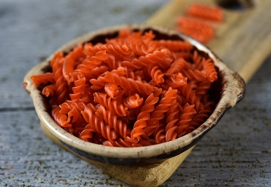
- Programs must indicate that pasta made of vegetable flour is a ‘vegetable’ and not a grain. For example, pasta made of chickpea flour could be labeled on menus as ‘Chickpea Pasta’ and indicated as the vegetable component. Programs can also use signs or other nutrition education materials.

SURIMI SEAFOOD
Surimi seafood is a pasteurized, ready-to-eat, restructured seafood usually made from pollock (fish) that credits as a meat/meat alternate. The crediting information is in the chart below:
Some surimi products may be made with higher percentages of m/ma ingredients; therefore, to credit surimi differently than what is listed in the chart obtain a CN label or PFS.
Surimi Seafood | Meat/Meat Alternate
4.4 ounces | 1.5 ounce m/ma
3.0 ounces | 1.0 ounce m/ma
1.0 ounces | 0.25 ounce m/ma

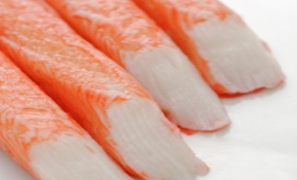
- Surimi is available in many forms and shapes, including chunks, shredded, and flaked, and does not require additional preparation.
- Can be incorporated into a variety of menu items, such as seafood salads, sushi-style rolls, sandwiches, tacos, and ramen.

Links to USDA Policy Memos

- Shelf-Stable, Dried and Semi-Dried Meat, Poultry, and Seafood Products (CACFP 08-2019 Crediting Shelf-Stable, Dried and Semi-Dried Meat, Poultry, and Seafood Products in the Child Nutrition Programs)
- Coconut, Hominy, Corn Masa, and Corn Flour (CACFP 09-2019: Crediting Coconut, Hominy, Corn Masa, and Corn Flour in the Child Nutrition Programs)
- Tempeh (CACFP 12-2019: Crediting Tempeh in the Child Nutrition Programs)
- Popcorn (CACFP 10-2019: Crediting Popcorn in the Child Nutrition Programs)
- Pasta Products Made of Vegetable Flour (CACFP 13-2019: Crediting Pasta Products Made of Vegetable Flour in the Child Nutrition Programs)
- Surimi Seafood (CACFP 11-2019: Crediting Surimi Seafood in the Child Nutrition Programs)

North Dakota Department of Public Instruction Child Nutrition and Food Distribution www.nd.gov/dpi/
This institution is an equal opportunity provider.

