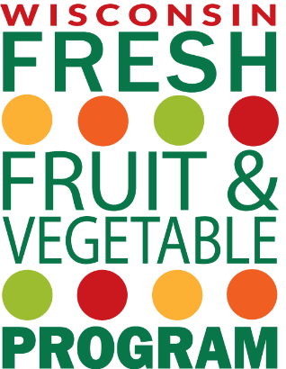

Date

Dear Parents and Guardians,

We are happy to announce that Elementary School Name was selected to participate in the U.S. Department of Agriculture’s (USDA) Fresh Fruit and Vegetable Program (FFVP) during the 2023-24 school year.
The goals of this grant program are to:
- Create healthier school environments by offering healthier choices.
- Expand the variety of fruits and vegetables children experience.
- Increase children’s fruit and vegetable consumption.
- Make a difference in children’s diets to impact their current and future health.
A fresh fruit or vegetable snack will be offered to your student approximately [Number of times] of times per week. FFVP snacks will generally be served mid-morning /early afternoon.
Teachers will provide nutrition education activities in the classroom to increase students’ knowledge of the health benefits of eating fruits and vegetables. The FFVP is an excellent way to supplement other wellness programs in the school that promote health, nutrition, and physical activity.
You can support your student’s efforts to increase his or her fruit and vegetable consumption in many ways. For example:
- Take your student grocery shopping. Let your student assist in selecting a new fruit or veggie to try.
- Give your student options! Let your student choose which veggie to serve at dinner some nights.
- Keep fruits and vegetables where your student can see them, such as on the counter.
- Take your student to a local farmers’ market and discover which fruits and vegetables are in season.
- Be a role model! If your child sees you eating fruits and veggies regularly, he or she will be more likely to eat them.
More information about the FFVP can be found at the Wisconsin Department of Public Instruction Fresh Fruit and Vegetable Program website (dpi.wi.gov/school-nutrition/programs/fresh-fruit-vegetable). If you have questions, please contact me at email or phone number.
Sincerely,
Name

Nondiscrimination Statement for USDA Child Nutrition Programs (Updated May 2022)
In accordance with federal civil rights law and U.S. Department of Agriculture (USDA) civil rights regulations and policies, this institution is prohibited from discriminating on the basis of race, color, national origin, sex (including gender identity and sexual orientation), disability, age, or reprisal or retaliation for prior civil rights activity.
Program information may be made available in languages other than English. Persons with disabilities who require alternative means of communication to obtain program information (e.g., Braille, large print, audiotape, American Sign Language), should contact the responsible state or local agency that administers the program or USDA’s TARGET Center at (202) 720-2600 (voice and TTY) or contact USDA through the Federal Relay Service at (800) 877-8339.
To file a program discrimination complaint, a Complainant should complete a Form AD-3027, USDA Program Discrimination Complaint Form which can be obtained online at: https://www.usda.gov/sites/default/files/documents/USDA-OASCR%20P-Complaint-Form-0508-0002-508-11-28-17Fax2Mail.pdf, from any USDA office, by calling (866) 632-9992, or by writing a letter addressed to USDA. The letter must contain the complainant’s name, address, telephone number, and a written description of the alleged discriminatory action in sufficient detail to inform the Assistant Secretary for Civil Rights (ASCR) about the nature and date of an alleged civil rights violation. The completed AD-3027 form or letter must be submitted to USDA by:
- mail:
U.S. Department of Agriculture
Office of the Assistant Secretary for Civil Rights
1400 Independence Avenue, SW
Washington, D.C. 20250-9410; or
- fax:
(833) 256-1665 or (202) 690-7442; or
- email:
program.intake@usda.gov
This institution is an equal opportunity provider.

